AHSANULLAH UNIVERSITY OF SCIENCE AND TECHNOLOGY

Lab Report

K-Nearest Neighbors (KNN)

Author: Mentor:
Saadmaan Asif Islam Hasan Mahmud
sadman0510@gmail.com

Contents
Introduction 3
Objective 4
Implementation 5
Result Analysis 7
Conclusion 7

INTRODUCTION
The K-NEARESR NEIGHBOR (KNN) algorithm is a non-parametric method used for classification and regression. In both cases, the input consists of the k closest training examples in the feature space. The output depends on whether KNN is used for classification or regression.

Neighborhood size:
- Choice of k
- smaller k ⇒ higher variance (less stable)
- larger k ⇒ higher bias (less precise)
- Proper choice of k depends on the data:
  - Adaptive methods, heuristics
  - Cross-validation

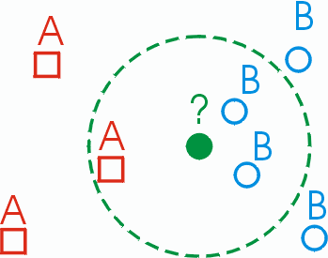
Figure 1: K Nearest Neighbor example

OBJECTIVE
1. Determine parameter K = number of nearest neighbors.
- Suppose use K = 3

2. Calculate the distance between the query-instance and all the training samples.
- Coordinate of query instance is (3, 7), instead of calculating the distance we compute square distance.
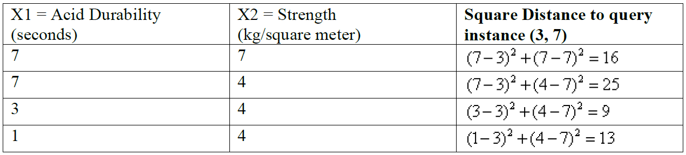
3. Sort the distance and determine nearest neighbors based on the K^{th} minimum distance.
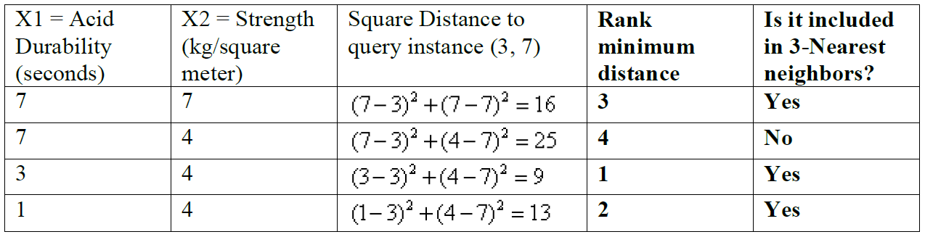
4. Gather the category (Y) of the nearest neighbors.
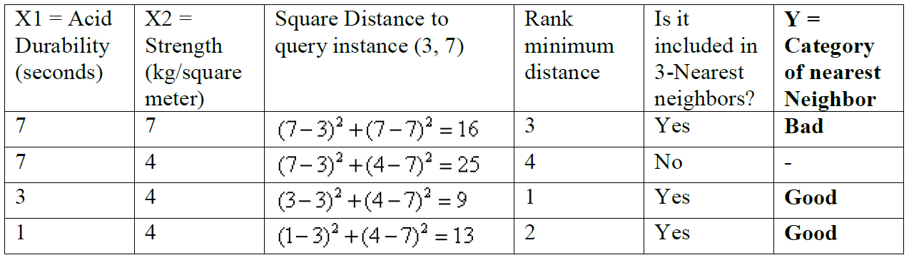
5. Use simple majority of the category of nearest neighbors as the prediction value of the query instance.

IMPLEMENTATION
Task -1 & 2: Determine parameter K & Calculate the distance between the query-instance and all the training samples
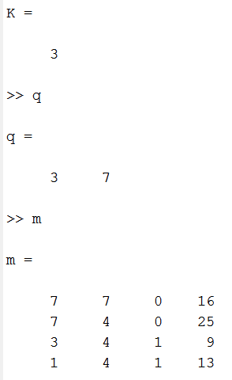

MATLAB CODE
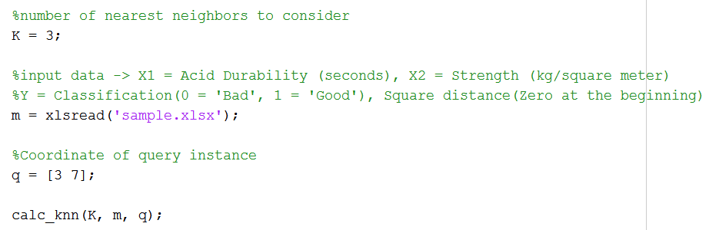
Figure 2: code segment 1.1

Task -3: Sort the distance and determine nearest neighbors based on the K^{th} minimum distance.
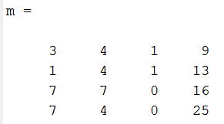

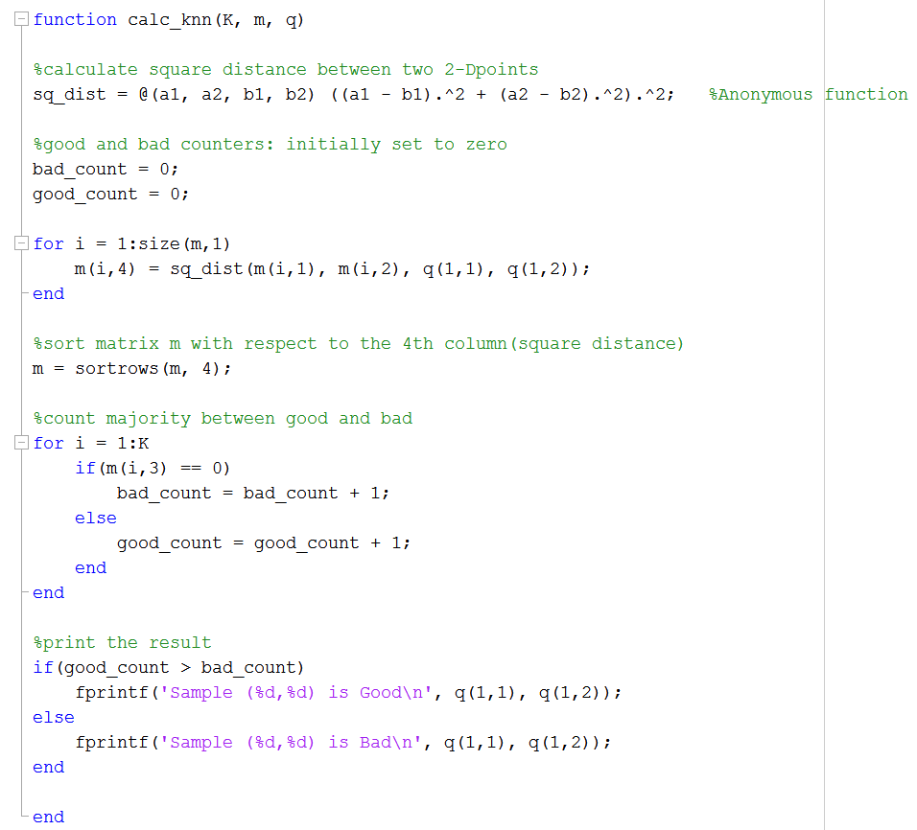
Figure 3: code segment 1.2

Task -4 & 5: Gather the category (Y) of the nearest neighbors and use simple majority of the category of nearest neighbors as the prediction value

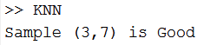
Figure 4: result of the code segment 1.2

RESULT ANALYSIS
We have 2 good and 1 bad, since 2 > 1 then we conclude that a new paper tissue that pass laboratory test with X1 = 3 and X2 = 7 is included in Good category.

CONCLUSION
The purpose of the k Nearest Neighbors (KNN) algorithm is to use a database in which the data points are separated into several separate classes to predict the classiﬁcation of a new sample point. This sort of situation is best motivated through examples.

